# **Course: Object-Oriented Programming**

# **Lab 08**

**Polymorphism**

**Task 1:**

Make a class **CommissionEmployee** that is inherited by **BasePlusCommissionEmployee.** Class **CommissionEmployee** has four private attribute firstName, LastName, grossSales and commissionRate. Create a fully parameterized constructor. In this class, you have to check that grossSales must be greater than zero and commissionRate must be greater than zero and less than 1. This class has 2 methods, *earnings()* and *toString().* You can calculate earnings of employee using this formula: commissionRate*grossSales.

Make a class **BasePlusCommissionEmployee** that has one private attribute baseSalary. Create a fully parameterized constructor. In this class, you have to check that baseSalary must be greater than 500. This class overrides both methods *earnings()* and *toString().* You can calculate earnings of employee using this formula: commissionRate*grossSales*baseSalary.

In the test class, get the firstName, lastName, grossSale, commissionRate and baseSalary from user and call *toString()* and *earnings()* methods.

**Task 2:**

Make a class Faculty that is inherited by 2 classes PermanentFaculty and VisitingFaculty.

Class Faculty has two attributes id and name, fully parametrized constructor and calculateSalary() method.

Class PermanentFaculty has one attribute salary, fully parametrized constructor and overrides calculateSalary() method.

Class VisitingFaculty() has two attributes hours,salaryPerHr, fully parametrized constructor and overrides calculateSalary() method.

In PermanantFaculty class, *calculateSalry* method returns basic salary. In VisitingFaculty class, *calculateSalry* method returns hours*salaryPerHr.

In Test class create an array of Faculty (n elements) and ask user which object data to enter, 1 for PermanentFaculty, 2 for Visiting. Input data for appropriate object and save in the array.

After n objects are saved, show salary of all objects through polymorphic processing.

Now update salary of permanantFaculty by 10%. (HINT: You will have to first check for required Faculty using the instanceof operator, then, you will have to downcast to set appropriate value of the object)

**Expected Output:**

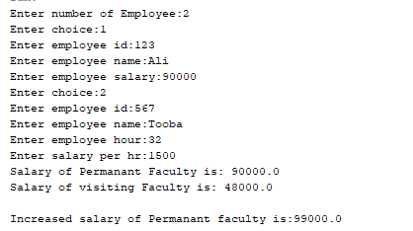

**Task 3:**

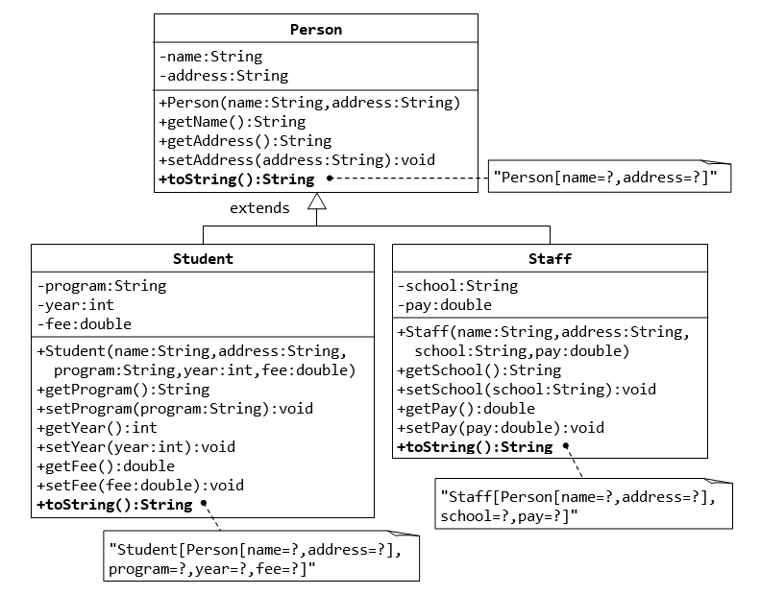

In main class, create an ArrayList of Person (3 elements). Ask user which object data to enter, 1 for staff, 2 for student. Input data for appropriate object and save in the ArrayList. After 3 objects are saved, show all objects (using the toString method) through polymorphic processing.

**Expected Output:**

